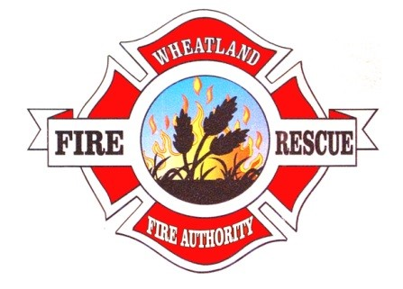

**WHEATLAND FIRE AUTHORITY**

**BOARD OF DIRECTORS**

**REGULAR MEETING NOTICE**

NOTICE IS HEREBY GIVEN that the Chair of the Wheatland Fire Authority Board of Directors has called a regular meeting of the Board of Directors to be held on October 13, 2022, at 6:00 p.m. at the Wheatland Fire Authority Station No. 3, 4514 Dairy Road, Wheatland, California. Members of the public may address the Board of Directors concerning any item described below during the Board’s consideration of that item. The Chair will invite public comment following Board discussion/deliberation of the item and, if applicable, before Board action.

In compliance with the Americans with Disabilities Act, if you are a disabled person and you need a disability related modification or accommodation to participate in this meeting, please contact Art Paquette, Fire Chief at 530-682-9819. Requests must be made as early as possible.

The following business shall be considered and transacted:

1. Call to order and roll call.
2. Pledge of Allegiance to the Flag.
3. At this time, the public is permitted to address the Board on non-agenized items. COMMENTS SHOULD NOT EXCEED THREE (3) MINUTES. In accordance with State Law, however, no action or discussion may take place on any item not appearing on the posted agenda. The Board may respond to statements made or questions asked or may request Staff to report back at a future meeting concerning the matter. Any member of the public may contact the Fire Chief’s Office related to the proper procedure to place an item on a future Wheatland Fire Authority agenda. The exceptions under which the Board MAY discuss and/or act on items not appearing on the agenda are contained in Government Code §54954.2(b) (1) (2) (3).
4. Approve minutes from the July 14, 2022, meeting.
5. Approval of ATD Exposure Control Plan
6. Old Business
7. New Business
8. Treasurer Report

11. Chief’s Reports.

12. Adjourn.